The Battle of Neighborhoods

Report

Introduction

For expansion in business, finding the right location to build Italian restaurants in Montreal where there aren’t many is the goal in this project.

Data

We will map the amount of restaurants in Montreal where we will get it from FourSquare API.

Methodology

K means clustering is used to identify the k number of centroids after getting the list of neighbourhoods in Montreal.

Results

The diagrams below show the 2 main segments obtained.

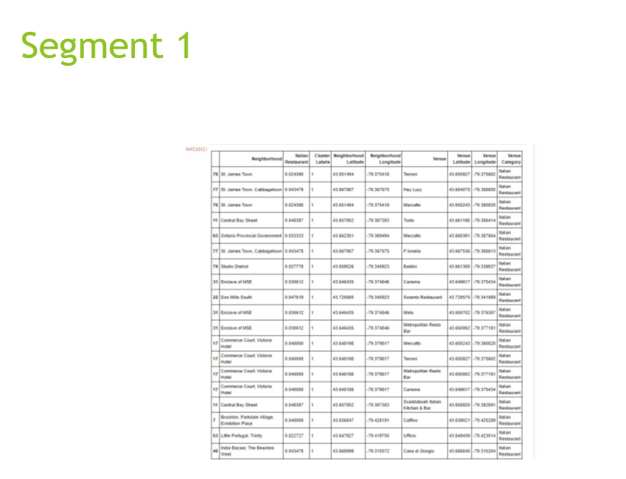

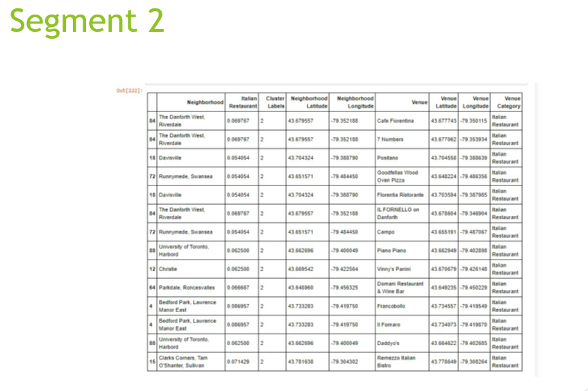

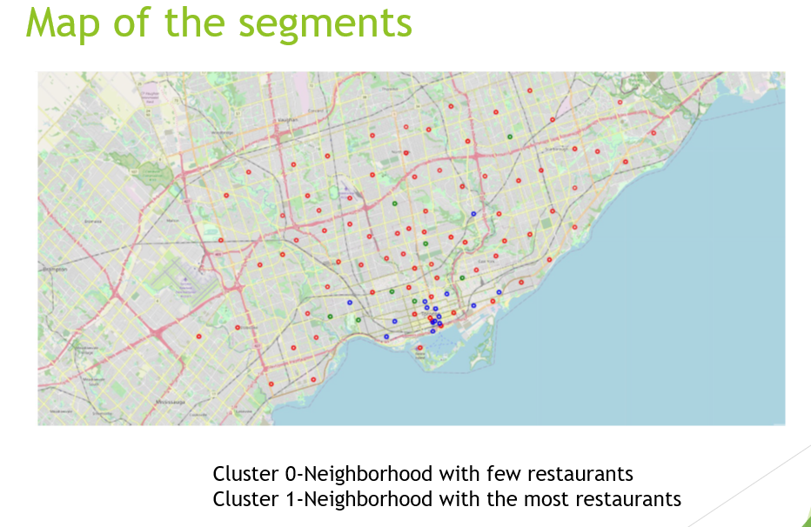

Conclusion

We recommend to build more Italian restaurants in Cluster O which has the least number of restaurants